Project Design Phase-II
Solution Requirements (Functional & Non-functional)
Date | 07 July 2026
Team ID | SWTID-2026-2247
Project Name | Emotion Detection and Learning Support Engine
Maximum Marks | 4 Marks

Functional Requirements:
Following are the functional requirements of the proposed solution.
FR No. | Functional Requirement (Epic) | Sub Requirement (Story / Sub-Task)
FR-1 | User Registration | - Registration through Form  - Registration through Gmail  - Registration through LinkedIn
FR-2 | User Confirmation | - Confirmation via Email  - Confirmation via OTP
FR-3 | Emotion Detection | - Facial expression detection through webcam feed  - Voice tone and speech pattern analysis  - Text sentiment analysis from chat/quiz responses
FR-4 | Learning Support Recommendation | - Personalized content suggestions based on detected emotion  - Adaptive difficulty adjustment of learning material  - Break/relaxation activity suggestions when stress or fatigue is detected
FR-5 | Dashboard & Analytics | - Student emotion-trend dashboard  - Teacher/parent monitoring dashboard  - Weekly emotion-learning progress reports
FR-6 | Feedback & Alerts | - Real-time alert to teacher on negative emotion spikes  - Student self-feedback and mood check-in option  - Notification system for timely interventions

Non-functional Requirements:
Following are the non-functional requirements of the proposed solution.
FR No. | Non-Functional Requirement | Description
NFR-1 | Usability | The system shall provide a simple, intuitive interface for students, teachers, and parents, requiring minimal training, and shall follow accessibility guidelines (WCAG 2.1) for inclusive use.
NFR-2 | Security | All emotion, biometric, and learning data shall be encrypted in transit and at rest, with role-based access control and compliance with data privacy regulations such as GDPR/FERPA.
NFR-3 | Reliability | The system shall maintain consistent and accurate emotion detection results, with robust error handling and automatic recovery in case of module failure.
NFR-4 | Performance | Emotion detection and recommendation generation shall complete within 2 seconds, supporting real-time processing of video, audio, and text streams.
NFR-5 | Availability | The system shall be available 24/7 with a minimum uptime of 99.5%, supported by redundant servers and cloud-based deployment.
NFR-6 | Scalability | The architecture shall scale from a single classroom to district/institution-wide deployment, supporting 100,000+ concurrent users through a microservices-based design.

System Diagrams:

1. System Architecture Diagram
The diagram below illustrates the overall architecture of the Emotion Detection and Learning Support Engine, showing how input data flows from capture through emotion classification into the learning support engine, and finally to recommendations, dashboards, and alerts.
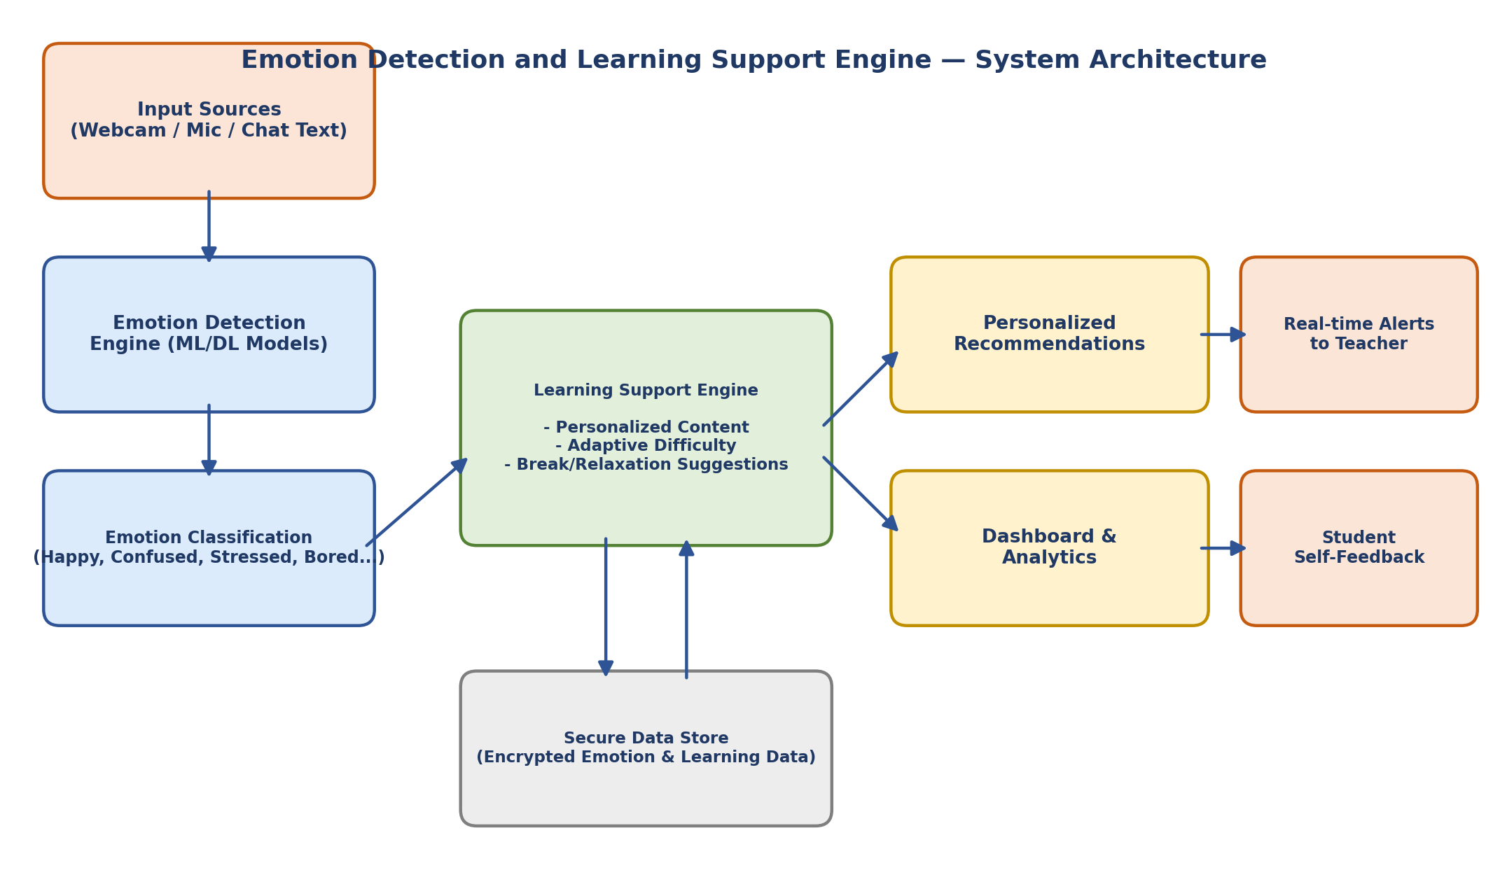

2. Process Flow Diagram
The process flow below shows the step-by-step journey of a student interacting with the system, from login to real-time emotional analysis, adaptive content delivery, and dashboard updates for teachers.
